Why make snow in Boise?
Boise is a prime location to employ snowmaking to establish a small cross country ski trail system. It has an active, outdoors-driven, community, and a strong core of dedicated Nordic skiers. It has a growing population of both children and active older residents for whom cross country skiing is a natural fit - particularly if they could be introduced to it at a location only a few minutes from home. Lack of consistent snow in the valley, and the drive to Bogus Basin hamper the potential of Boise’s skiing community.

Can Snow be made in Boise?
Gateway Park on Eagle Island successfully made snow during the past four winters for their freestyle terrain parks and tubing hills. Estimates by HKD Snowmakers show that in six of the last seven years we could have opened by December 15 with 18 inches of snow across 3 kilometers of trail with an average opening date of November 30.

Who would benefit?
Probably the biggest beneficiaries would be local kids. The easy access would allow for afterschool programs to develop and grow. The Bogus Basin Nordic Team currently has around 90 kids in the program. The “refuski” program through the Bogus Basin Nordic Team currently supports 7 refugees between 3rd and 8th grade. Beyond the kids - local athletes could cross train and residents could take up a new form of recreation that they could complete before or after work – without being stuck inside! Cross country skiing is a lifetime sport and can be done with the entire family.

Has this been done before?
Around the country and the world many cross country ski areas have become dependent on snowmaking. The cross country skiing events at the Olympic games in Pyeongchang were contested entirely on man-made snow. Perhaps our best comparable is the snowmaking system at Edina High School (outside of Minneapolis, MN). They were seeing fewer and fewer days with enough natural snow, so the high school ski team purchased snowmaking equipment for a 1 kilometer loop. Their team had 140 kids in 2014 when they put in the system and had over 200 this winter.

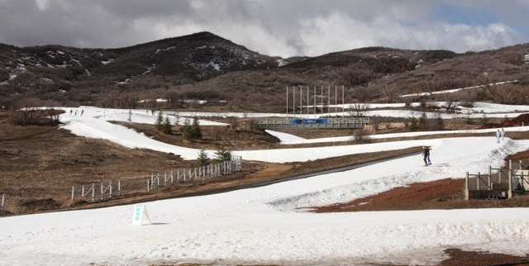
Soldier Hollow, Utah – NCAA Championships March 2014
Common Concerns

Noise – Most of us have been to Sun Valley or another ski resort town and heard the rushing noise of the snow-guns at night. What we’re looking to do, however, is entirely different. First, while those resorts run with hundreds of guns all firing at once, we’re looking to use just 5-6 guns. More importantly, snow guns have come a long way in the last 10-20 years.
At high snowmaking temperatures 27-32 degrees Fahrenheit HKD Snowmakers measured the decibels produced their Impulse Snow Gun (we’re looking at the Impulse and Phasar Models).
73 decibels at 50 feet
70 decibels at 100 feet
65 decibels at 150 feet
For comparisons sake at 10 feet a weed eater is as high as 95 decibels while in use. Classroom chatter is approximately 70 decibels.
Moreover, our primary snowmaking zone is ~1000 feet from the nearest houses and the school.

Water – We plan to draw our water from the creek in Stewart Gulch. Snowmaking is often considered a non-consumptive use as most of the water ends up back in the watershed. As soon as we have permission to be on the property we can go about securing the water rights.

How much will it cost?
As far as snow-sports go, cross country skiing is relatively inexpensive. While prices haven’t been set they will likely be similar to those offered at Bogus Basin. Adult Prices will be $10-15 for a day pass and $150-200 for a season pass.

Funding – We are not planning to request any money from either the City of Boise or the Boise Independent School district – all funding will be private. As a 501 C-3 nonprofit, all donations are considered tax deductible.
To purchase the equipment and run the area for one season will require around $500,000 in donations. After the first season we expect the trail system to be self-funded through trail passes, lessons, rentals, and concessions. If we are unable to reach our target for donations, we have a scaled down “plan-b” version of the plan that will only cost $200,000.

Other Users – Walking and snowshoeing will not be permitted on the ski trails. That said, we’ll be certain to maintain a corridor that the public can use to access the Highland Hollows walking and hiking trails.

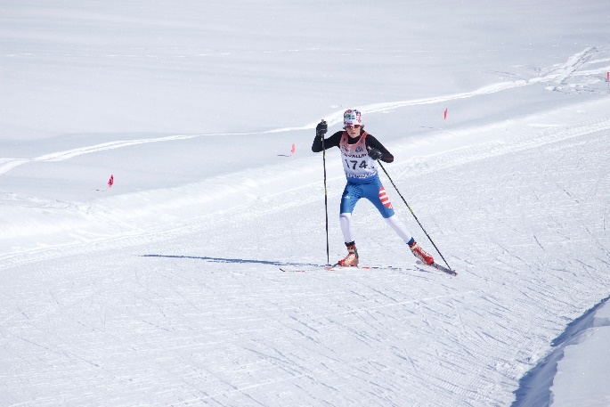
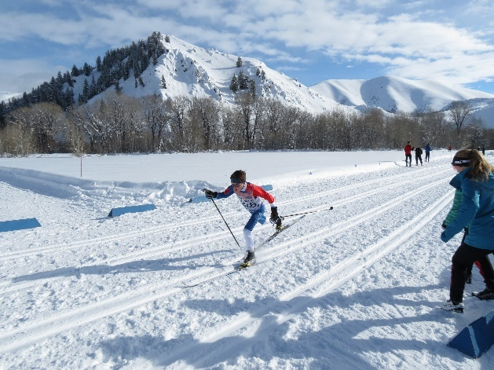
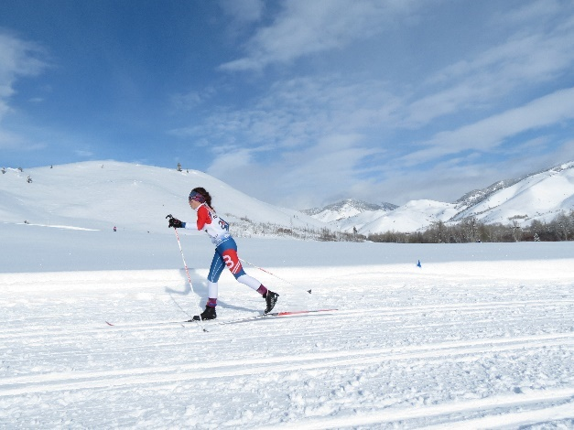
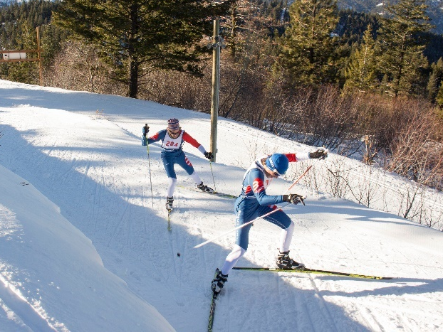
What is Cross Country Skiing
Skate Skiing uses a lateral push off that is very similar to ice skating or roller-blading. Ski point out in a “V” shape. Poles are used at the same time for each push.
There are two types of cross country skiing - Classic and Skate.

Classic skiing uses a rearward push off on one ski, and kind of looks like running. Some skis have what are called “fish-scales” on the bottom to grip the snow. Other skis are smooth and use a sticky wax call “Kick-Wax” for traction.

Most people would agree that classic is easier to learn, but harder to master than skating.

Cross country skiing is one of the best sports that you can do for your health – it is low impact, aerobic, and it challenges both strength and endurance. When the streets are snow and ice covered and it’s too dangerous to run or bike you can still safely cross country ski.
Perhaps most importantly, cross country skiing is a lifetime sport. Five year-olds and 95 year-olds can all participate.

